CENTRAL BUCKS SCHOOL DISTRICT
2024-25 BRIDGE VALLEY FACILITY USE REQUEST FORM

Return To: BRIDGE VALLEY MAIN OFFICE Inclement Weather Hotline (267) 893-4020 (Option #5)
Fill in top section of this form and return to the building you are requesting to use. PLEASE EMAIL TO JOANNE HAMILTON (jhamilton@cbsd.org) or HEATHER GALE (hgale@cbsd.org)

SCHOOL REQUESTED:Bridge Valley | Date of Request:
Rooms Requested:  □ Gym  □ Cafeteria  □ All-Purpose Room/LGI Upstairs  □ All-Purpose Room/LGI Downstairs  - Classroom(s) How many?  - Auditorium  - Library  - Community Room  - Stage  - Other ________________ | Requestor’s Name: __________________________  Phone Number: ______________________________  Date of Event: ________________________________  Start Time (include set up time) ________________  Ending Time (include clean up time) _____________  Number expected to attend _________  Adults__________ Children ____________  Contact Cell #  ***CBSD EVENTS ONLY  Name of person supervising:
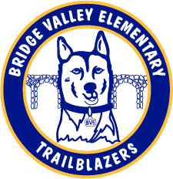
Technology Requested:  - Podium  - Projector/Screen  - Microphone  - Clear Touch  - Computer Cart  - Extension Cord  - Other-- __________________ | Cell #:
 | Type of Event or Program (meeting, basketball, etc.)
Equipment Needed
Chairs(#): Tables(#): Risers(#): Other
 | Description of Event/Program (Please include a flyer if applicable)
Sketch of Layout of Space:
 | Building Principal Approval:
 | (Signature) | (Date)
 | (Group Member Signature) ( Date)

